ENGG1340 Computer Programming II

**Module 5 Checkpoint Exercise**

Name: Adrio Alimin

University ID: 3035603978

**Instructions:**

For each single question or each group of questions in the Checkpoint exercise, please type your answer right after the question in this Word document.

**Checkpoint 5.1 (Please submit your answer to Moodle)**

Error(s) may include in the following sub-questions. If you think there is/are error(s), try to find out and suggest some way(s) to fix the error(s). If no error, please write “No error”.

a) 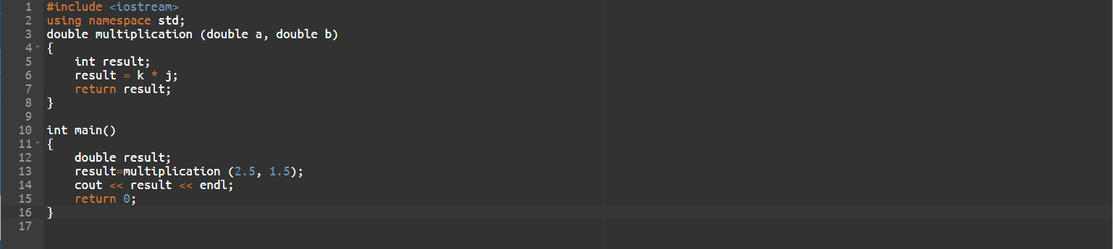

i. The identifiers **k** and **j** were not declared before they were referenced. (line 6); change their names to a and b instead.

ii. **multiplication** attempts to return an integer (**result**) even though its method signature identifies it as a double-returning function.(line 7); declare result as a **double** instead.

iii. Assuming **k** and **j** are **doubles** **a** and **b**, multiplying them and setting the result to the **integer** variable **result** will cause a loss of information. (line 5); solved in i. and ii.

b)

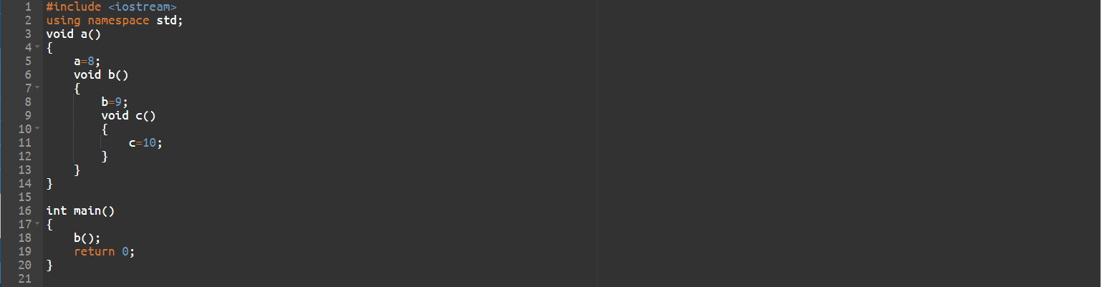

1. Nested functions are not allowed in C++ (except if you do lambdas); declare **b** and **c** outside the **a** function body but before **main** (and **c** outside **b**).
2. **a, b, c** isn’t declared at any point in the file; one solution would be to put int in front of their assignment statements, say **int a=8;**

**Checkpoint 5.2 (Please submit your answer to Moodle)**

Write down the (i) function header; (ii) function prototype (without parameter names), for each of the following functions:

1. A function called largest that takes four double-precision, floating-point arguments, a, b, c and d, and returns a double-precision, floating-point as the result.
2. Function header (otherwise known as method/function signature)

**double largest(double a, double b, double c, double d)**

1. Function prototype (otherwise known as function declaration)

**double largest(double, double, double, double);**

1. A function called getPerimeter that does not take any arguments and returns an integer as the result.
   1. Function header

**int getPerimeter()**

* 1. Function prototype

**int getPerimeter();**

1. A function called setPrice that takes a double-precision, floating-point argument, price, and does not return a value.
   1. Function header

**void setPrice(double price)**

* 1. Function prototype

**void setPrice(double);**

**Checkpoint 5.3 (Please submit your answer to Moodle)**

Student A writes the following code. However, when he compiles the code, some compilation errors are found.

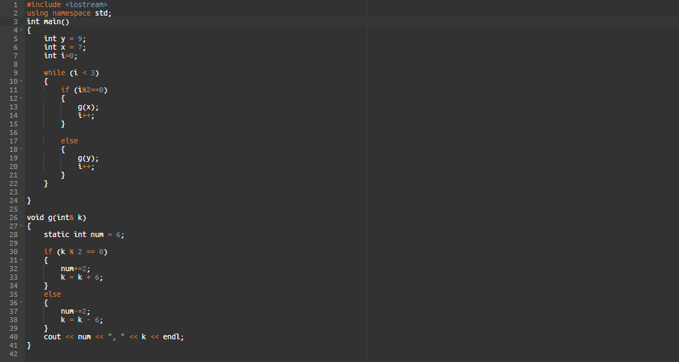

1. Find out the errors and suggest some ways to fix the errors.
   1. **g** (which was defined further down the file than **main**) is being called in **main** without firstly being declared; A should declare it after the ***using***line and before **main**, e.g. **void g(int &k).**
   2. **g’s** pass-by-reference parameter is declared using wrong syntax; it should be **int &k**.
2. Write down the program output after you fix the errors in (a).

**4, 1**

**2, 3**

**0, -5**

**Checkpoint 5.4 (Please submit your answer to Moodle)**

Given the following program:

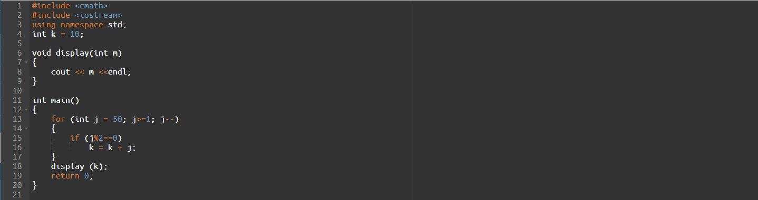

1. What is the scope of variable k?

global

1. What is the scope of formal parameter m?

Within **display**

1. What is the scope of variable j?

Within the for loop in **main**.